**COMSATS University Islamabad,   
Abbottabad Campus**

**Project Proposal   
(SCOPE DOCUMENT)**

**for**

**AI-Assisted Learning Management System**  
Version 0.1

***By***

**Hanzla Nouman CIIT/FA21-BSE-015/ATD**

**Laiba Binta Tahir CIIT/FA21-BSE-019/ATD**

**Arfah Ali CIIT/FA21-BSE-080/ATD**

***Supervisor*Mr. Mukhtiar Zamin**

***Bachelor of Science in Computer Science (2021-2025)***

|  |  |  |
| --- | --- | --- |
| **No.** | **Comment** | **Action** |
|  |  |  |
|  |  |  |
|  |  |  |
|  |  |  |
|  |  |  |
|  |  |  |

**SCOPE DOCUMENT REVSION HISTORY**

**Supervisor Signature**

**Date**

**Table of Contents**

**Introduction** 5

**Problem Solution for Proposed System** 5

**Advantages/Benefits of Proposed System** 7

**Modules** 7

**Module 1: Content Generation** 7

**Module 2: Content Recommendation** 8

**Module 3: Self Evaluation** 8

**Module 4: Standard Evaluation** 8

**Module 5: Analytics** 8

**Module 6: Operational Tasks (Attendance)** 8

**System Limitations/Constraints** 9

**Software Process Methodology** 9

**Tools and Technologies** 10

**Project Stakeholders and Roles** 11

**Team Members Individual Tasks/Work Division** 12

**Data Gathering Approach** 12

**Concepts** 12

**Gantt chart** 14

**Mockups** 15

**Conclusion** 16

**References** 16

**Plagiarism Report** 17

**Project Category:**

**B-**Web Application/Web Application based Information System

** E-** Smartphone Application

**Abstract**

This project proposal describes an AI-Assisted Learning Management System (LMS) which is designed to transform the educational experience for both educators and learners. This LMS includes advanced AI features, meaning that it focuses on automated generation of learning materials, personalized content recommendations, evaluation with AI, and AI insights help to enhance learning outcomes and overcome challenges of traditional LMS. The goal of the project is to create a platform that allow teachers to help students learn on a personalized basis and provide students with the necessary learning materials based on their preference and performance.

**Introduction**

This project proposal aims to outline an AI-assisted Learning Management System (LMS) that automates key elements of education and possesses AI driven insights. Traditional LMS platforms are limited in their adaptability to diverse learning needs and fail to personalize the educational experience. These limitations are addressed by our AI-Assisted LMS by including modules like; content creation, personalized recommendations, evaluation support and analytics that are automated and adaptive to a student’s profile. The aim of this platform is to reduce the routine tasks of teachers and enhance the quality of education being offered. Also, gives the students an adaptive learning environment, to help them grow and make the learning experience smoother.

**Problem Statement**

Personalized LMS platforms are virtually non-existent. Traditional LMS requires excessive amounts of teacher’s time in content creation, grading and analysis. Because of these constraints, teachers cannot provide more than one approach to learning, while in most cases students do not have any support tailored for them. Additionally, there are no AI recommendations or feedback systems within existing LMS, so student engagement data is not utilized for further resources or for any content modification. To fill in these gaps, we aimed the AI Assisted LMS, which automatically generates content, personalizes recommendations, and automates grading with AI. Our motivation is to learn and apply advanced AI techniques in education by developing this system.

**Problem Solution for Proposed System**

The AI-Assisted LMS intend a multi-module system to overcome the shortcomings existent in the traditional LMS platforms. In the module of Content Generation and Recommendation Engine (CGRe), teachers can generate content in form of lectures and supporting materials for the course with the help of AI thus minimizing the time taken in preparation. The AI-Assisted Evaluation module offers automated grading of self-assignments and standard assessments while allowing teachers to check only assessment responses that were flagged. The system also provides students with tailored lecture notes and views of study material dependent on their metrics. With the use of data analytics, the teachers can track the students’ performances and adjust their teaching styles accordingly.

**Related System Analysis/Literature Review**

1. **Canvas LMS:** Canvas is the most popular learning management system aimed at course management and student tracking. However, AI driven content generation and adaptive features are not included in this LMS. Its feedback functionality is quite basic and often requires manual input from instructors for personalized feedback.
2. **Blackboard Learn:** Blackboard Learn offers comprehensive course management and analytics but in AI content personalization its limited. Also, its grading and recommendation systems are not highly adaptive.
3. **Google Classroom:** Google classroom LMS was aimed at assignment management and collaboration. It lacks automated grading and personalized content recommendation, making it less robust for data driven insights and personalized learning experience.

**Table 1: Related System Analysis with Proposed Project Solution**

|  |  |  |
| --- | --- | --- |
| **Application Name** | **Weakness** | **Proposed Project Solution** |
| **Canvas LMS** | Limited adaptive learning & AI-driven content creation features. | The proposed system’s Content Generation and Recommendation Engine (CGRe) helps teachers create interactive content, while AI-powered recommendations provide students with tailored study materials. |
| **Blackboard Learn** | Limited personalization in grading and content recommendation.  Analytics are focused on risk identification rather than adaptive learning. | The AI-Assisted Evaluation module allows automated grading with customizable feedback, while analytics provide adaptive learning insights, supporting both personalized feedback and content adjustments. |
| **Google Classroom** | Lacks in-depth analytics, automated grading, and personalized content suggestions. | The proposed system offers AI-driven grading, performance analytics, and adaptive content recommendations, making the learning experience more tailored and data-informed. |

**Summary of Contributions to the Proposed Project**

Our multi-module AI-Assisted LMS overcomes the primary limitation of LMS platforms. Using the Content Generation and Recommendation Engine (CGRe), a teacher can develop well-structured lectures, and other course content with AI assistance, which saves a lot of time for preparation. System allows automation in assignment grading, feedback which can be tailored and selective view of assignment by the teacher. There are also features in which students are given specific study materials or perspectives which are programmed according to their performance metrics. Analytics offer information to teachers with regards to respective students which contribute to modifying how the students can be taught. With this systematic approach, students get the personalized teaching experience in a variety of ways, which results in higher level of engagement and learning.

**Advantages/Benefits of Proposed System**

* Minimizes the amount of time teachers devote to content generation and marking activities.
* Provides personalized learning materials tailored to each student’s performance.
* Empower teachers to make data-driven decisions through real-time analytics.
* Encourages efficient self-styled assessment and feedback cycles supported by AI-assisted evaluation.
* Facilitates the adaptive content recommendations for continuous student improvement.
* Fits into existing course material which assists in the implantation process.
* Motivate students to learn via customized learning pathways.

**Scope**

The project aims to develop an LMS that is AI-assisted having four core features: content generation, personalized recommendations, AI driven evaluation, and data analytics. The system is aimed at improving the education sector and will provide teachers with AI powered tools for generating lectures and assessing students based on performance trends. Students will have personalized learning materials and specific suggestions automated to their studying needs.

This LMS will not include such operational features as timetable management, report cards, diaries, real-time communication, or parent engagement features., but rather focusing solely on AI driven educational tools. By narrowing its scope, the project advocates for efficient resource use while delivering impactful, targeted learning support. Future iterations may explore expanded administrative functionalities.

**Modules**

**Module 1: Content Generation**

This module supports teachers and students in creating and organizing educational content, providing tools for lecture creation, resource organization, and interactive content development.

**Functionalities**:

1. **Create Lecture**: Enables teachers to build and structure lecture content, adding text, images, videos, and interactive quizzes.
2. **AI-Generated Content**: Provides AI-assisted content suggestions based on input topics, course objectives, and existing resources.
3. **Save and Publish**: Allows teachers to save lecture drafts or publish them for student access.
4. **Add Multimedia Elements**: Supports embedding of multimedia (e.g., videos, images) to enhance lecture content.
5. **Personal Notetaking**: Allows students to create personalized notes and summaries based on lecture content.
6. **Edit and Update Content**: Teachers can modify lecture content as needed to improve relevance or clarity.

**Module 2: Content Recommendation**

This module delivers personalized study resources to students, adapting content recommendations based on their individual needs, schedules, and performance.

**Functionalities**:

1. **Personalized Resource Suggestions**: Recommends additional study materials or resources based on each student’s performance, preferences, and progress.
2. **Weakness Area Identification**: Analyzes performance data to identify areas needing additional practice, guiding students to relevant topics.
3. **Dynamic Learning Pathway**: Adjusts recommended content pathways as students progress through courses, promoting mastery in specific topics.
4. **Teacher Insight Dashboard**: Provides teachers with data on recommended materials for students, helping them understand areas needing reinforcement.
5. **Content Bookmarking**: Allows students to save recommended content for future study sessions.

**Module 3: Self Evaluation**

This module empowers students to assess their knowledge through quizzes and practice exercises, providing feedback and insights into their understanding of course topics.

**Functionalities**:

1. **Customizable Quizzes**: Allows students to select specific topics for self-assessment, generating personalized quizzes.
2. **Instant Feedback**: Provides immediate feedback with explanations, helping students understand their mistakes and correct misconceptions.
3. **Progress Tracking**: Tracks students’ progress on self-evaluation activities over time, helping students monitor improvement.
4. **Performance Summary**: Displays a summary of quiz results, highlighting strengths and areas for improvement.
5. **Review Incorrect Answers**: Allows students to review questions they answered incorrectly with additional explanations or resources.

**Module 4: Standard Evaluation**

The Standard Evaluation module supports formal assessments conducted by teachers, offering grading options that are consistent and objective.

**Functionalities**:

1. **Create and Schedule Assessments**: Teachers can create quizzes, exams, and assignments and schedule them for specific dates.
2. **AI-Assisted Grading**: Automatically grades quizzes and assignments based on predefined rubrics, saving time for teachers.
3. **Manual Grading Adjustments**: Allows teachers to review AI-graded responses, making manual adjustments as needed.
4. **Feedback Provision**: Enables teachers to provide detailed feedback on student submissions, reinforcing learning.
5. **Rubric Customization**: Teachers can define custom grading rubrics, allowing for consistency across assessments.
6. **Low-Score Review**: Flags low scores for teacher review, ensuring struggling students receive targeted feedback.
7. **Result Publishing**: Teachers can publish results, making scores and feedback available to students.

**Module 5: Analytics**

This module provides data insights into student performance, engagement, and topic mastery, enabling teachers to tailor their instruction and students to track their progress.

**Functionalities**:

1. **Engagement Metrics**: Measures student engagement with course content, tracking metrics like time spent and completion rates.
2. **Topic Mastery Tracking**: Analyzes which topics students have mastered and where they struggle, offering insights for targeted support.
3. **Class Performance Overview**: Gives teachers a high-level view of class performance, helping identify common challenges among students.
4. **Individual Performance Reports**: Shows detailed progress reports for each student, enabling personalized feedback and support.
5. **Behavioral Analytics**: Tracks patterns in student study habits and engagement, helping predict academic success or risk.
6. **Improvement Tracking**: Monitors student performance over time, showing progress and growth in specific skills or knowledge areas.
7. **Exportable Reports**: Allows teachers to export data reports for administrative reviews or parental meetings.

**Module 6: Attendance**

1. **Automated Attendance Recording**: Teachers can take a picture of the classroom using the app, and the system will automatically identify and mark attendance based on face recognition.
2. **Real-Time Validation**: Ensures accuracy by cross-verifying attendance data with the student database in real time.
3. **Attendance Reports**: Generates detailed attendance reports for teachers to review trends and identify frequently absent students.
4. **Notifications**: Sends automated notifications to students or guardians about attendance status, if required.
5. **Privacy and Security**: Uses secure protocols to ensure student data, including facial recognition data, is protected and complies with data privacy regulations.

**System Limitations/Constraints**

1. **Limited Administrative Features**: the proposed LMS will be directed at certain AI-supported educational tools, which will not include the development of administrative functions such as making a timetable, drawing a report card, diaries, real time communication. These can be investigated in future development, but they are not in the scope of the present project.
2. **Dependence on Accurate Data**: The AI-generated content, recommendations, and evaluations depend on having reliable and relevant performance data from students. Limited or inconsistent data may adversely affect the success of personalized recommendations.
3. **Hardware and Software Compatibility**: Due to the demand for AI algorithms, specific hardware requirements and software setups possess problems of universal compatibility with less powerful or old systems.
4. **Privacy and Data Security Constraints**: Sensitive information about student performance is being managed using the LMS which means that these databases will have to enforce strong levels of data security and privacy at the expense of resource allocation and data regulations compliance.

**Software Process Methodology**

For our AI-Assisted LMS, we have chosen the **Component-Based Software Engineering (CBSE)** methodology, which aligns with our technology stack and project requirements. With our frontend and backend implemented in TypeScript (Node or Deno), mobile application in Flutter with Dart, and AI models based on Python libraries, CBSE provides a modular, scalable approach well-suited to this diverse ecosystem.

CBSE allows us to design each feature as an independent, reusable component. Key functionalities such as the Content Generation and Recommendation Engine, AI-Assisted Evaluation, and Data Analytics modules can be developed, tested, and deployed individually, ensuring flexibility in development. This methodology supports seamless integration across different components, enabling our AI models, frontend, and backend to work together efficiently while maintaining codebase consistency.

Furthermore, CBSE facilitates scalability, allowing us to add additional features or modify existing ones without disrupting other components. This adaptability will be essential as we aim to introduce extensive administrative features in future iterations. In summary, CBSE enhances the reusability and maintainability of our LMS, making it the ideal methodology for our AI-enhanced, component-focused project.Top of FormBottom of Form

**Tools and Technologies**

|  |  |  |  |
| --- | --- | --- | --- |
| Tools and Technologies | Tools | Version | Rationale |
| IDE | Visual Studio Code | Latest | Code development for frontend and backend |
|  | Jupyter Notebooks | Latest | Experimentation and model training for ML |
|  | PyCharm | Latest | Python development, especially for ML models |
| Database and Data Management | MongoDB Atlas | Latest | Primary DBMS for storing LMS data |
|  | Pinecone or Weaviate | Latest | Vector database for content recommendation |
| Frontend Development | React | Latest | Frontend framework for web-based LMS |
|  | Next.js | Latest | Server-side rendering and SEO support |
| Backend Development | Node.js | Latest | Backend server to handle API requests |
|  | Express.js | Latest | Web framework for routing and handling API |
|  | NestJS | Latest | Backend framework for modular and scalable development |
| AI and Machine Learning | TensorFlow | Latest | Training and deploying ML models |
|  | PyTorch | Latest | Alternative ML framework for experimentation |
|  | OpenAI GPT API | Latest | Content generation and Q&A model through API |
|  | Llama.cpp | Latest | Lightweight deployment of Llama models locally |
| Recommendation Systems | Scikit-Learn | Latest | Simple collaborative and content-based filtering |
|  | LightFM | Latest | Hybrid recommender system |
| Data Processing and Analytics | Pandas | Latest | Data manipulation and preprocessing |
|  | Matplotlib | Latest | Visualization of analytics data |
|  | Plotly | Latest | Interactive data visualization |
| Documentation and Presentation | MS Word | Latest | Project documentation |
|  | MS PowerPoint | Latest | Presentations for stakeholders |
|  | Adobe XD | Latest | Wireframing and UI design |
| Deployment and Cloud Services | AWS EC2 | Latest | Hosting scalable cloud infrastructure |
|  | AWS S3 | Latest | Data storage for resources and files |
|  | Vercel | Latest | Frontend hosting for Next.js |
| Version Control | Git | Latest | Version control for collaborative coding |
|  | GitHub | Latest | Hosting repository and code reviews |
| Communication | Notion | Latest | Team communication and updates |
|  | Google Meet | Latest | Meetings and screen sharing for development |
| Mockups and Prototyping | Figma | Latest | Mockups and UI/UX design |
| Programming Languages | JavaScript (TypeScript) | ES6+ | Core language for web development |
|  | Python | 3.x | AI, ML, and backend scripting |
|  | HTML | 5 | Web content structuring |
|  | CSS | 3 | Styling for the frontend |

**Project Stakeholders and Roles**

**Table 3Project Stakeholders for Proposed Project**

|  |  |
| --- | --- |
| **Project Sponsor** | COMSATS University Islamabad, Abbottabad campus. |
| **Stakeholder** | * Project Supervisor: Mr. Mukhtiar Zamin * Developers: Hanzla, Laiba, Arfah * Final Year Project Committee * Head of Institute (School/College) * Students * Teachers * Administrator |

**Team Members Individual Tasks/Work Division**

**Table 4Team Member Work Division for Proposed Project**

|  |  |  |
| --- | --- | --- |
| **Student Name** | **Registration Number** | **Responsibility/ Modules** |
| Hanzla Nouman | FA21-BSE-015 | Module 1-2: Content Generation and Recommendation Engine (CGRe) |
| Laiba Binta Tahir | FA21-BSE-019 | Module 3-4: Self-evaluation and Standard evaluation |
| Arfah Ali | FA21-BSE-080 | Module 5-6 Analytics and Operational tasks |

**Data Gathering Approach**

We will conduct interview session with head of Ali grammar school, Wah Cantt, Pakistan to gather insights on challenges, needs and expectations related to LMS.

Furthermore, we will also conduct surveys with Students and Teachers of Ali Grammar School and other institutions if feasible via Google Forms or other questionnaires.

We will also be using data from an already running solution, Subject Expert – An LMS, available generally for over 6 Years, maintained by our respectable Supervisor, Ex-Microsoft, Ex-Hitachi Software Engineer Mr. Mukhtyar Zamin, on the premises of providing the Generation & Recommendation Engine for further development of their LMS to support the long-term evolution of Education system.

**Concepts**

***Concept-1: Retrieval-Augmented Generation (RAG)***

*An AI framework that combines information retrieval systems with generative language models to produce accurate and context-relevant content, enhancing the system's ability to generate educational materials tailored to specific needs.*

***Concept-2: Natural Language Processing (NLP)***

*Utilizing models like Llama 3.2 to understand and generate human-like text, enabling the system to create coherent lecture notes, quizzes, and personalized feedback for students.*

***Concept-3: Reinforcement Learning***

*A machine learning approach where models learn optimal actions through rewards and penalties, allowing continuous improvement of AI algorithms based on user interactions and new data within the LMS.*

***Concept-4: Clustering (Machine Learning)***

*A technique to group students based on performance, preferences, and interactions, facilitating personalized content recommendations and identifying areas where students may need additional support.*

***Concept-5: Data Repositories***

*Centralized storage of educational resources and student data that serve as the knowledge base for content generation and recommendation, ensuring the system has access to comprehensive and up-to-date information.*

***Concept-6: Item Response Theory (For Assessments)***

*A statistical framework used to model the relationship between a student's ability and their performance on assessment items, allowing for more accurate and fair evaluations tailored to individual proficiency levels.*

***Concept-7: Visualization Models***

*Tools and techniques for graphically representing data analytics, helping educators visualize student performance trends and engagement metrics for informed decision-making.*

*no*

***Concept-8: Regression Models***

*Statistical methods like linear regression used to predict student outcomes based on various input variables, aiding in early identification of students who may require additional assistance.*

***Concept-9: Decision Trees***

*A machine learning model that uses a tree-like structure of decisions to classify students' knowledge gaps, helping to customize learning paths by categorizing students as weak, average, or excellent in specific topics.*

**Gantt chart**

Figure 1: Sample Gantt chart

**Mockups**

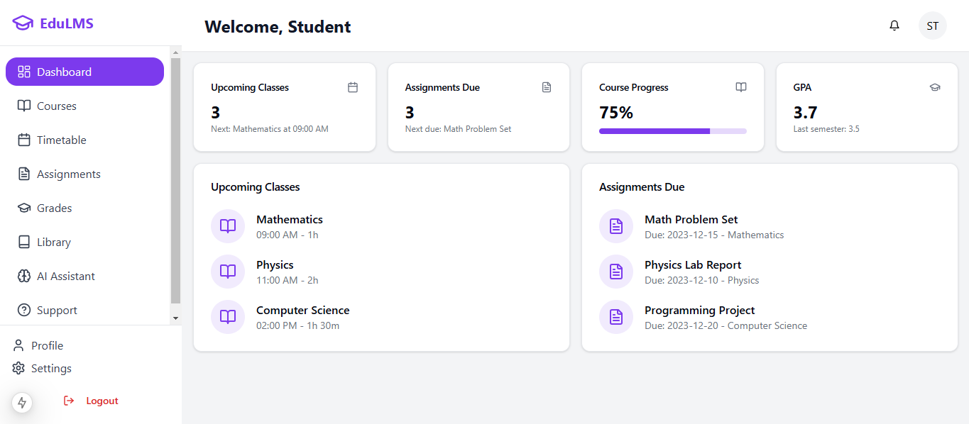

*Figure 2 LMS Dashboard*

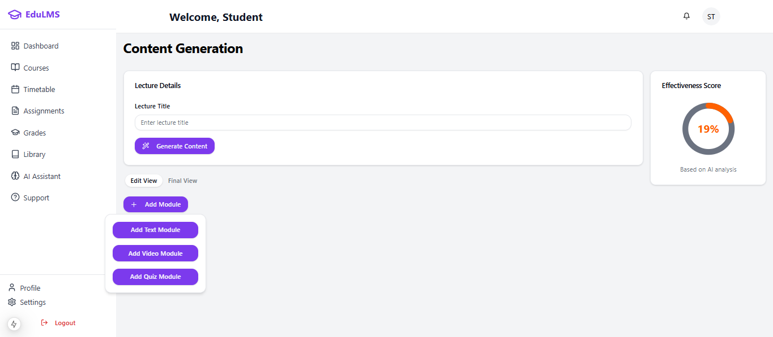

*Figure 3 Content Generation*

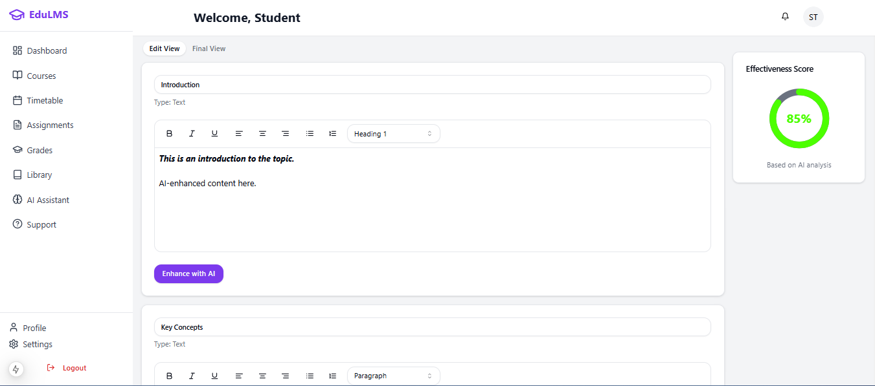

*Figure 4 Content Generation form I*

*Figure 5 Content generation form II*

*Figure 6Enrolled Courses*

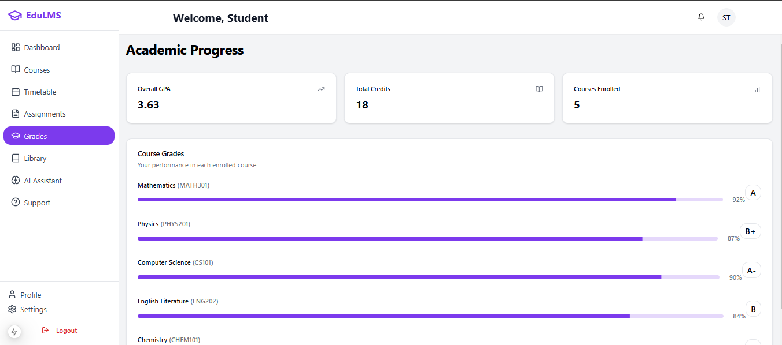

*Figure 7 Course Analytics Screen*

*Figure 8 Timetable Screen*

**Conclusion**

In summary, our AI-Assisted Learning Management System is going to revolutionize the educational experience. It addresses the needs that are not covered in the existing platforms by focusing on content generation, personalized recommendations, AI-driven evaluations, and data analytics through the integration of advanced AI features with traditional LMS functionalities. This project reduces the burden of educators while creating a personalized and adaptive learning environment for students. We are about to unveil a platform for enhanced learning outcomes and raise the standards in educational technology, being careful in design with modules and the integration of technologies that are front-line leaders.

**References**

* **Canvas LMS.** (n.d.). Instructure. Retrieved from https://www.instructure.com/canvas
* **Blackboard Learn.** (n.d.). Blackboard. Retrieved from https://www.blackboard.com/teach-learning/learning-management/blackboard-learn
* **Google Classroom.** (n.d.). Google. Retrieved from <https://classroom.google.com/>
* **Lewis, M., Liu, Y., Goyal, N., Ghazvininejad, M., Mohamed, A., Levy, O., ... & Zettlemoyer, L. (2020).** BART: Denoising Sequence-to-Sequence Pre-training for Natural Language Generation, Translation, and Comprehension. Proceedings of the 58th Annual Meeting of the Association for Computational Linguistics, 7871–7880.
* **Brown, T. B., Mann, B., Ryder, N., Subbiah, M., Kaplan, J., Dhariwal, P., ... & Amodei, D. (2020).** Language Models are Few-Shot Learners. Advances in Neural Information Processing Systems, 33, 1877-1901.
* **Lord, F. M. (1980).** Applications of Item Response Theory to Practical Testing Problems. Routledge.
* **Pedregosa, F., Varoquaux, G., Gramfort, A., Michel, V., Thirion, B., Grisel, O., ... & Duchesnay, É. (2011).** Scikit-learn: Machine Learning in Python. Journal of Machine Learning Research, 12, 2825-2830.
* **Breiman, L. (2001).** Random Forests. Machine Learning, 45(1), 5-32.
* **Goodfellow, I., Bengio, Y., & Courville, A. (2016).** Deep Learning. MIT Press.
* **van der Maaten, L., & Hinton, G. (2008).** Visualizing Data using t-SNE. Journal of Machine Learning Research, 9(Nov), 2579-2605.

**Plagiarism Report**

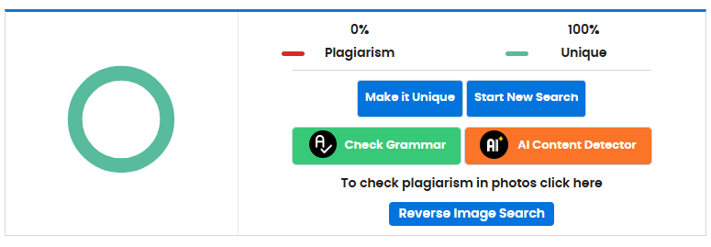

*Figure 9 Plagiarism Report*